UNIVERSITY OF WAH (UOW)
DEPARTMENT OF COMPUTER SCIENCE



BSCS 3RD B

REG #: UW-24-CS-BS-088

SUBMITTED BY: SAADI SAFDAR

SUBMITTED TO: SIR. HASSAN SHAFAQAT

COURSE TITLE: COMPUTER NETWORKS

COURSE CODE: CS – 241 L

MID LAB SESSIONAL

The network topology consisted of:

Routers: Three routers (likely Cisco 1841 or similar).

Switches: Three switches.

Hosts: Multiple PCs divided into two LANs.

Connections: Each router was connected to a switch, and the routers were linked directly by FastEthernet interface.

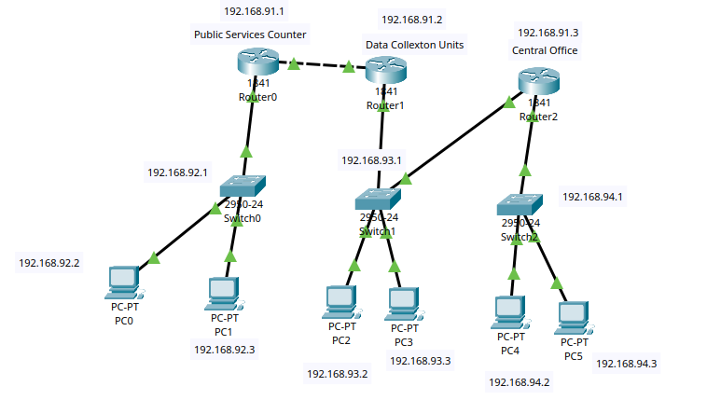
IP Confiquration for Routers
R0: 192.168.91.0
R1: 192.168.91.0
R2: 192.168.91.0

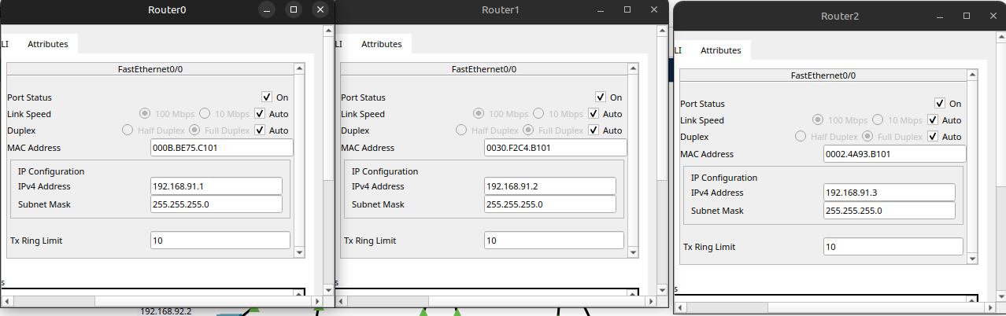
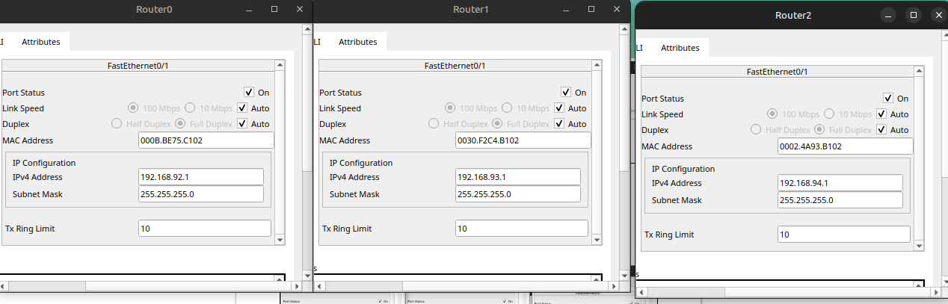
IP Cofiguration for all PCs.
